December 25, 2019

To Whom it may concern,

It is with great pleasure that I write this letter in support of Nevaeh Geske. Nevaeh is currently enrolled in my Urban Agriculture course this year. Nevaeh is one of those students who is unfortunately hard to find these days. Her passion and charisma is a pleasure to behold. Nevaeh maintains a strong commitment to her studies and does very well academically. Nevaeh not only excels academically, but is also a very talented cheerleader. How she manages to balance such a heavy workload is a testament to her dedication and commitment.
Nevaeh is the type of student that inspires me and makes me realize why I went into teaching. Although I have only had her in class less than a year, she made it a point to come out to my classroom and further her knowledge of plants and floral design. She is one of my more talented florists and is always there to help me with customer orders. I have learned that I can always rely on Neveah to get the job done. Each day Neveah arrives to class early and eager to learn, she demonstrates a willingness and eagerness to learn, lead and succeed. I wish more students embodied these characteristics. Thus making her a well-rounded and well-adjusted young lady.

Again it is with great pleasure that I write this letter in support of Neveah Geske. She is a remarkable young lady and deserves your most serious consideration.

Sincerely,
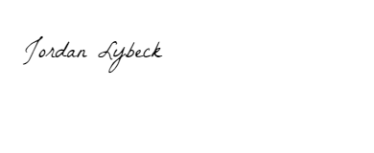
Jordan Lybeck
Agricultural Science instructor
Decatur High school
253-945-5265
Jlybeck@fwps.org

